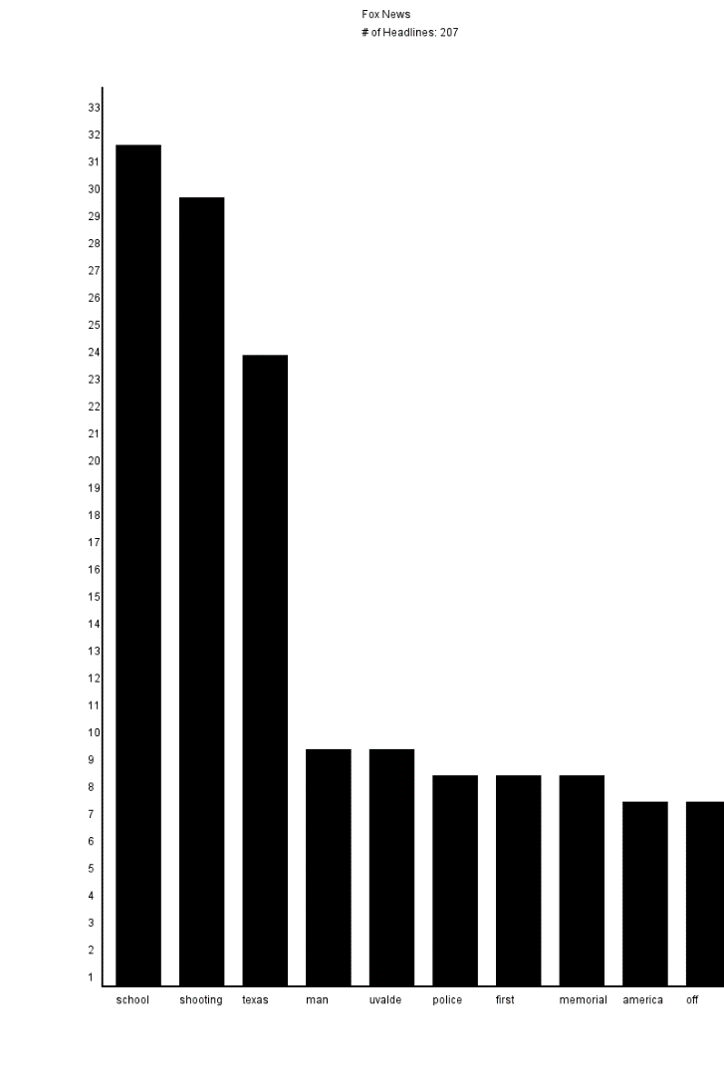

Fox News:  
MM§M  
MM§M# of Headlines: 207  
MM§M  
MM§M"school" appears 32 times  
MM§M"shooting" appears 30 times  
MM§M"texas" appears 24 times  
MM§M"man" appears 9 times  
MM§M"uvalde" appears 9 times  
MM§M"police" appears 8 times  
MM§M"first" appears 8 times  
MM§M"memorial" appears 8 times  
MM§M"america" appears 7 times  
MM§M"off" appears 7 times  
MM§M  
MM§MWashington Post:  
MM§M  
MM§M# of Headlines: 115  
MM§M  
MM§M"school" appears 7 times  
MM§M"his" appears 7 times  
MM§M"gun" appears 6 times  
MM§M"shooting" appears 5 times  
MM§M"police" appears 4 times  
MM§M"war" appears 4 times  
MM§M"first" appears 3 times  
MM§M"off" appears 3 times  
MM§M"violence" appears 3 times  
MM§M"americans" appears 3 times  
MM§M  
MM§MNews Max:  
MM§M  
MM§M# of Headlines: 42  
MM§M  
MM§M"texas" appears 6 times  
MM§M"school" appears 4 times  
MM§M"shooting" appears 3 times  
MM§M"abortion" appears 3 times  
MM§M"percent" appears 3 times  
MM§M"gun" appears 3 times  
MM§M"poll" appears 2 times  
MM§M"lack" appears 2 times  
MM§M"filling" appears 2 times  
MM§M"ukraine" appears 2 times  
MM§M  
MM§MNPR:  
MM§M  
MM§M# of Headlines: 37  
MM§M  
MM§M"shooting" appears 5 times  
MM§M"uvalde" appears 4 times  
MM§M"gun" appears 4 times  
MM§M"school" appears 4 times  
MM§M"shootings" appears 4 times  
MM§M"kids" appears 3 times  
MM§M"ukraine" appears 3 times  
MM§M"state" appears 3 times  
MM§M"texas" appears 3 times  
MM§M"mass" appears 3 times